Installation and Execution Steps
Automation Framework uses Robot Selenium Library. Robot Selenium‘s Firefox support is limited to Version 3.5.x. In future when the stable library version is released, user just needs to install the latest Robot-Selenium to make test-run under it. There is an open bug under on stated issue in robot framework.
Refer: http://code.google.com/p/robotframework-seleniumlibrary/issues/detail?id=99
Fedora 13 default comes with Firefox 3.6.x version, user needs to downgrade the Firefox version to 3.5.x. Secondly, to execute the test cases under firefox, user needs to create a ‘Firefox – User profile Template’
Why ‘Firefox – User profile Template’ is required?
Selenium launches a browser session (any browser session; IE or Firefox), it creates a user profile template (User profile template contains files which stores the information’s of the browser. This information includes the browser network setting details, cookies etc.). When Selenium launches any browser it creates a default profile with the default settings. (The main concern is on the proxy detection option, which will be ‘auto detect’ on firefox and IE browser). IE mostly detects the network with this option but Firefox won’t.
Selenium provides the flexibility to create a profile using a predefined one, so user needs to create a firefox user profile template and pass this as a parameter in the test script.
Note: If IE also doesn’t detect the network using the default setting; user needs to create a template for IE too.
Pre-requisites:
Windows:
- User should be logged in as administrator on the system to execute the automation scripts.
- The Wikipedia site should be accessible from the logged in system
Linux (Fedora):
- User should be logged in as administrator on the system to execute the automation scripts.
- The Wikipedia site should be accessible from the logged in system
- Firefox version should be 3.5.x
- Do not execute the scripts as root user as there is a bug in fedora while launching firefox user profile template from root user.
Pre-requisite software:
- Install Python 2.5.4
For Windows:
http://www.python.org/ftp/python/2.5.4/python-2.5.4.msi

Note: Follow the below mentioned steps to install
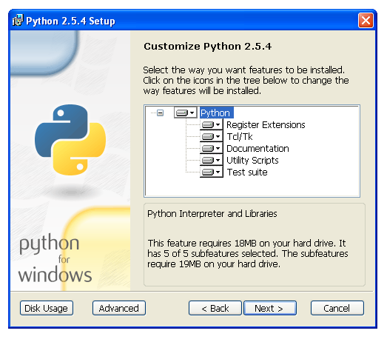

User needs to right click on `‘Python’ option and select ‘Entire feature will be installed on local hard drive’ on the pop-up. Refer the below screen shot.
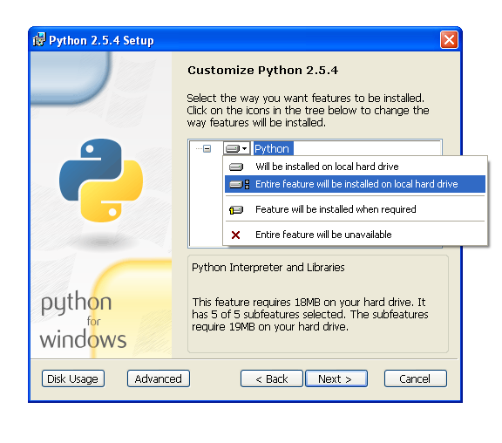
For Linux:
Python will be present by default (Python 2.6 in fedora 13)

- Install Robot framework (Robot framework version: 2.1.1)

For Windows:
http://robotframework.googlecode.com/files/robotframework-2.1.1.win32.exe

For Linux
Download.

http://robotframework.googlecode.com/files/robotframework-2.1.1.tar.gz

- Extract the file
- Open Terminal
- Navigate to Downloads folder
$ cd Downloads
- Navigate to the extracted folder in the Terminal
$ cd robotframework-2.1.1
- $ python setup.py install

- Install setup tools library for python, this is used to create an installer which will download the entire dependency library.

For Windows:
http://pypi.python.org/packages/2.5/s/setuptools/setuptools-0.6c11.win32-py2.5.exe#md5=cb0cd7b844bed5106aeb0d4583848b1f

For Linux:
Download.
http://pypi.python.org/packages/source/s/setuptools/setuptools-0.6c11.tar.gz#md5=7df2a529a074f613b509fb44feefe74e
- Extract the file
- Open Terminal
- Navigate to Downloads folder
- $ cd Downloads
- Navigate to the extracted folder in the Terminal
- $ cd setuptools-0.6c11-2.1.1
- $ python setup.py install

- Install JRE ( Java Runtime Environment ) V1.5
(Recommended Installation path – DEFAULT)

For Windows
http://javadl.sun.com/webapps/download/AutoDL?BundleId=39494

For Linux:
- Open Terminal
- $ su root
<Enter password >
- $ yum install java-1.6.0-openjdk-plugin
Wait until downloading and installation finishes
Refer: http://forums.fedoraforum.org/showthread.php?t=205473
- Install Selenium Library for Robot Framework (version 2.1.1)

For Windows
http://robotframework-seleniumlibrary.googlecode.com/files/robotframework-seleniumlibrary-2.2.1.win32.exe
For Linux:
Download
http://robotframework-seleniumlibrary.googlecode.com/files/robotframework-seleniumlibrary-2.2.1.tar.gz
- Extract the file
- Open Terminal
- Navigate to Downloads folder
$ cd Downloads
- Navigate to the extracted folder in the Terminal
$ cd robotframework-seleniumlibrary-2.2.1
- $ python setup.py install

- Install latest WikiBabelSelenium Library form Deliverables.
For Windows:
- Extract ‘Library.zip’ from the deliverables.
- Open folder ‘Library /WikiBhashaSelenium’ and verify ‘Installer.bat’ is present.
- Double click ‘Installer.bat’ to install the library.
- Verify the info logs for the successful installation of the library.

For Linux:
- Extract the file
- Open Terminal
- Navigate to the extracted folder in the Terminal
$ cd Downloads/WikiBhashaDeliverables/Library/WikiBhashaselenium
- $ python setup.py install

- Set Environment path for running tests.
For Windows:
User needs to make JRE and Robot Framework's runner scripts easily available from the command line.
Step to edit the environment variable is:
Start -> Settings -> Control Panel -> System -> Advanced -> Environment Variables
- Under “System Variables”, select Path and click on Edit
Enter the following information at the end
“;C:\Python25\Scripts\;C:\Python25\;C:\Program Files\Java\jre6\bin\;”

User needs to a add a new variable for Java

Start -> Settings -> Control Panel -> System -> Advanced -> Environment Variables
- Under “System Variables”, click New, enter the following:
- Variable Name – JAVA_HOME
- Variable value - C:\Program Files\Java\jre6\bin\;
Close all the windows
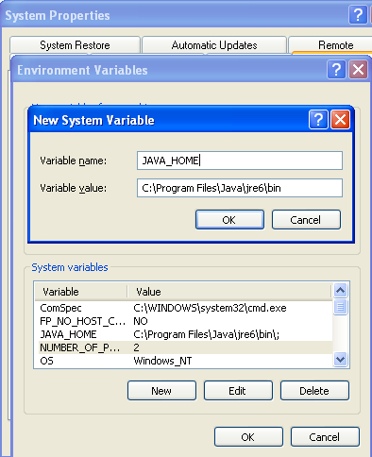

Note: On Windows XP the navigation to set environment differs, our main aim is to set path variables and JAVA_HOME
For Linux:
Linux does not requires for on setting environment values

These steps will successfully install the Framework with the required libraries into your system.

Test Execution Steps:
Pre-requisites:
For Windows:
- Get the latest Test Cases for IE from the deliverables an extract it.
- Open Folder ‘IE’ in the deliverables. (It contains the test-cases and the test execution script.
- Execute the test cases by double clicking ‘RunScript_IE.bat’
For Linux:
- Get the latest Test Cases for Firefox from the deliverables an extract it.
- Open Folder ‘Firefox’ in the deliverables. (It contains the test-cases and the test execution script.
- Open file “RunScript_FF” on any editor.
- Copy the entire content.
- Open the Terminal
- Execute the below commands.
{{{
$ cd Downloads/WikiBhashaDeliverables/TestScripts/Firefox
}}}
- Paste the copied content and execute.
Note: Currently Only BVT test cases has been Automated

How to modify the Run script file for specific needs:
- If you need to run a specific test-case then need to pass --test option with the test-case name.
‘--test <test-case name>’
- If you need to run a specific suite name then need to pass --suite option with the test-case name.
‘--suite <suite name>’
- If you want change the target language then need to pass --variable wbLang option with the target language name.
‘--variable wbLang:<target language>’
Along with that you need change five parameters in the ‘TestScripts\wbTestCasesIE\Common\CommonKeywords.html’ file.
You have to change the first 5 ‘Configuration variables’ in the file. These parameters are:
- ${SourceSearchTextExist}: this is the target language article name which exists in the target language Wikipedia as well as in source language (English) Wikipedia.
- ${SourceSearchTextNotExist}: this is the target language article name which exists in the target language Wikipedia but doesn’t exists in source language (English) Wikipedia.
- ${TargetSearchTextExist}: this is the source language article name which exists in the target language Wikipedia as well as in source language (English) Wikipedia. This should be article name of the ${SourceSearchTextExist} parameter in the source language(English)
- ${TargetSearchTextNotExist} : this is the Source language article name which exists in the source language Wikipedia but doesn’t exists in target language (English) Wikipedia.
- ${SearchText}: any search term preferable a keyword which has search result in source as well as in target language Wikipedia.

Few sample CommonKeywords.html files for different languages are provided in the ‘TestScripts\wbTestCasesIE\Common\’ folder.

- If you want to run the test cases for firefox then need to change BROWSER: option to the following
‘BROWSER:*firefox’
- For pointing the test cases to use WikiBhasha deployed in a remote location then you need to pass the path to bookmark page to the option --variable wbURL:
‘--variable wbURL:<path to install page of the remote deployed WikiBhasha instance’
- If you need to change the reporting destination then replace the ‘reports’ with the required destination (can be relative or absolute path).
- If you need to run only a specified test-suite then replace the "WikiBhashaTestCases" with the full path of suite file.html (can be relative or absolute path).

How to downgrade the Firefox version to 3.5.8 and create a Firefox user profile template?
Follow the below steps:

- Create Folder named 'WikiBhashaFireFoxTemplate'. This is to store the newly created Firefox
- Open Terminal and follow the below commands:
{{{
$ su root
<Enter password>
$ tar xfvj <Firefox download name> Ex. firefox-3.5rc2.tar.bz2
$ mv firefox /usr/lib/
$ cd /usr/lib/
$ ln -s /usr/lib/firefox/firefox /usr/bin/firefox
}}}
- Close the terminal.
- Open another terminal (don’t use the above terminal)
- Execute the below command
{{{

$ firefox -P
}}}
- This will Open a "Firefox - Choose User Profile" dialog
- Uncheck 'Don’t ask as startup' checkbox.
- Click on 'Create Profile...' button. This will navigate to 'Create profile Wizard'
- Click on 'Next'.
- Type 'WikiBabelFireFoxTemplate' in the text box
- Click on "Choose Folder.."
- Point the path to Downloads/WikibaBhashaDeliverables/TestScripts/FireFox/WikiBabelFireFoxTemplate
- Click on 'Finish' Button you are successfully done with the creating the profile template.
- Click 'Start Firefox', will open firefox.
- Check whether the browser setting allows you to browse.
- If yes close the browser, else change the browser setting. These changes will get stored in this very new created template.

Known Issues:
- Selenium Support is only IE7 (The only issue with IE8 is that it doesn’t closes the browser after test execution).
- Selenium Support is till Firefox 3.5 (Doesn’t support Firefox 3.6 at all).

